Tell me about
your child

What is your child’s favorite thing to do on the weekends?

________________________________________________________________________________________________________________________________________________________
What is your child’s  favorite color?  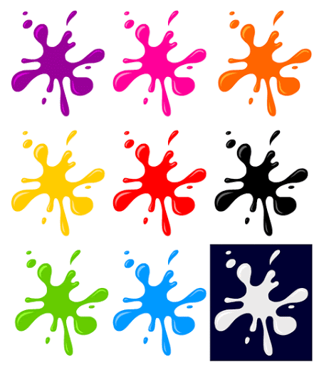  Other:___________________ | What is your child’s favorite  school subject?  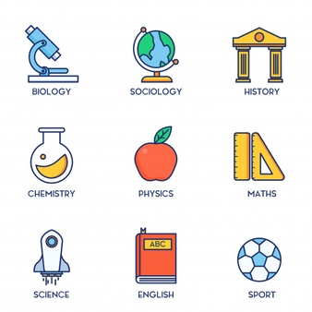  Other:_________________________
What do you do when your child is angry or sad?
________________________________________________________________________________________________________________________________________________________

What is your child’s favorite music to listen to?  Favorite TV show?  Favorite activity after school? |  | What is your child’s favorite food?  ____________________________________  Anything else you want to share?  ____________________________________

